**Issue 11:** The field “CITY” is a free form field instead of dropdown

**Description:** It would be good to have the field “CITY” as dropdown. The city dropdown should populate a list based on the “STATE OR PROVINCE” he/she selected. 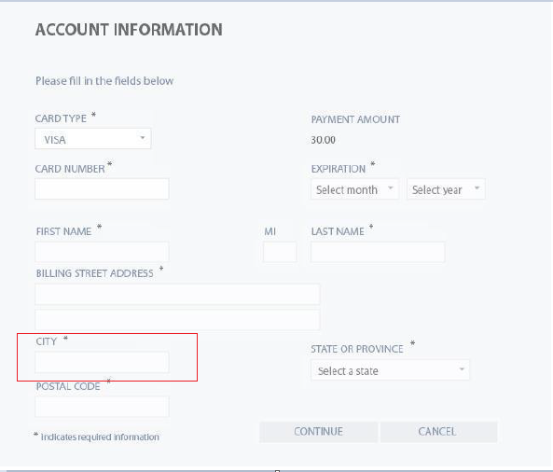

**Expected Behavior**: The field “CITY” should be a dropdown. It should populate a list based on the selection of the field “STATE”

**Severity**: Minor